

**How to manage website**

**How to customize website header**

-To change logo and add or remove new links in a website's header click on any page

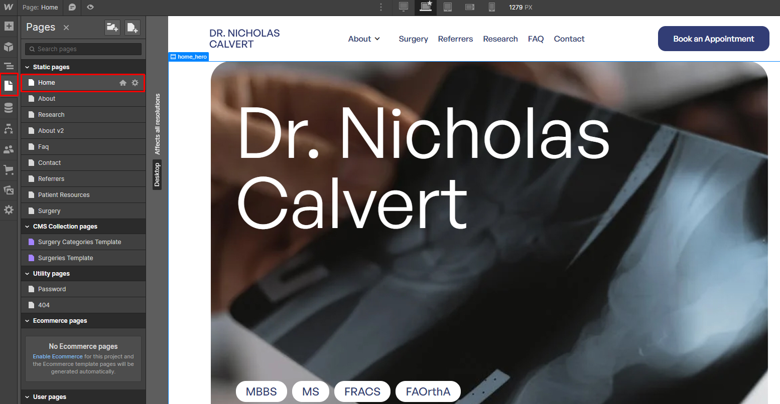

--Click on the Navigator button to select the header then click on the edit icon

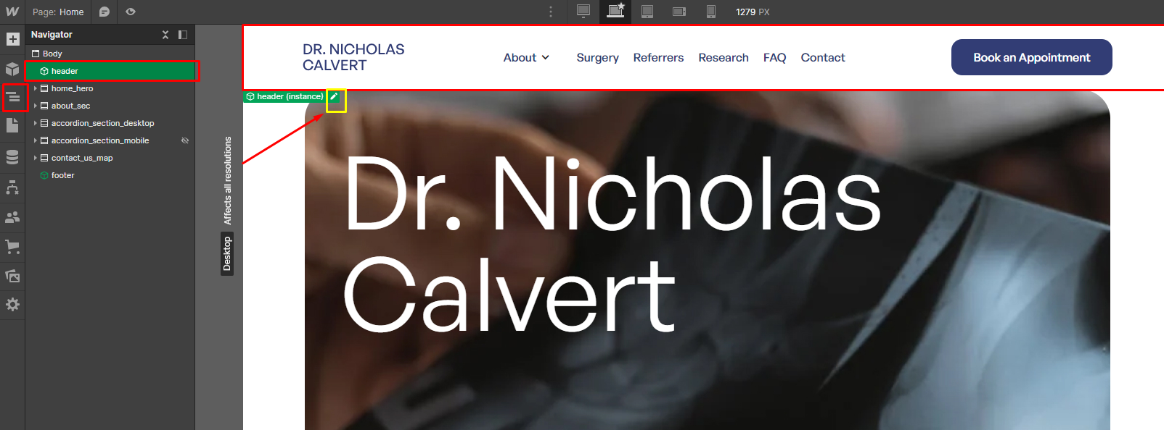

—Now you can change logo and add or remove links from the header.

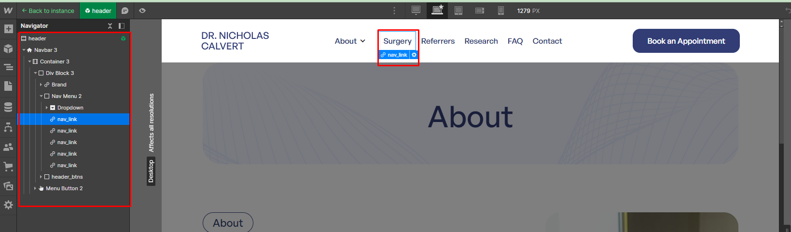

**How to change the content of a section on a page.**

**Home Page:-**

# **\*Hero section (Home page)**

-To change the image in the hero section of the home page, you can click on the "home_banner" element in the Navigator on the left side. Then, in the right sidebar style panel, you can change its background image. Additionally, you can modify the text by click on particular element, as shown in the screenshot below.

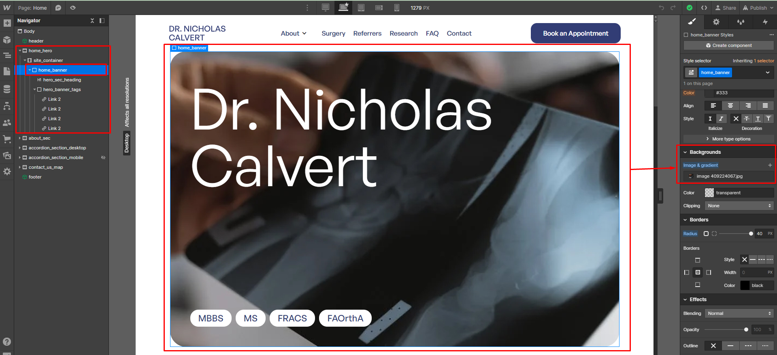

# **\*About section (Home page)**

–To change the text and image in the "**About**" section of the homepage, you can select the respective element from the left-side Navigator and then edit it, as shown in the screenshot below.

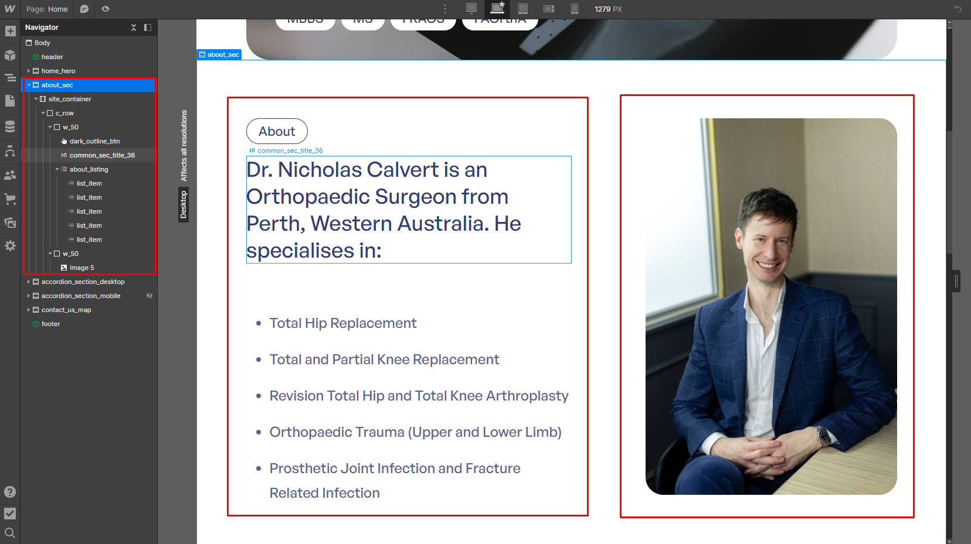

# **\*Accordion section “(Education, experience and research)” (Home page)**

–Due to different designs for desktop and mobile, we have created separate elements for the Accordion section. To change the content of the Accordion section, you will need to edit the content in both elements. We have created one element for desktop called "**accordion_section_desktop**" and another for mobile called "**accordion_section_mobile**," as shown in the screenshot below.

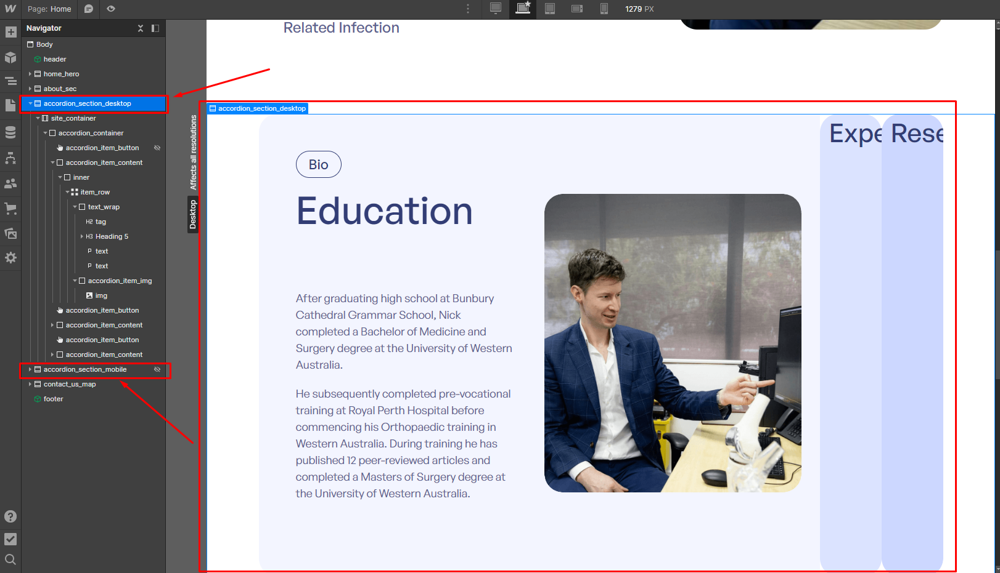

# 

# 

# 

# 

# **Accordion section for Desktop**

–To change the content of the "**accordion_item_button**" and "**accordion_item_content**" element in the accordion section, you need to add the "**active**" class for editing, and after making changes, remember to remove it.

However, keep in mind that you should initially add the "**active**" class to the first item to display it by default.

as shown in the screenshot below.

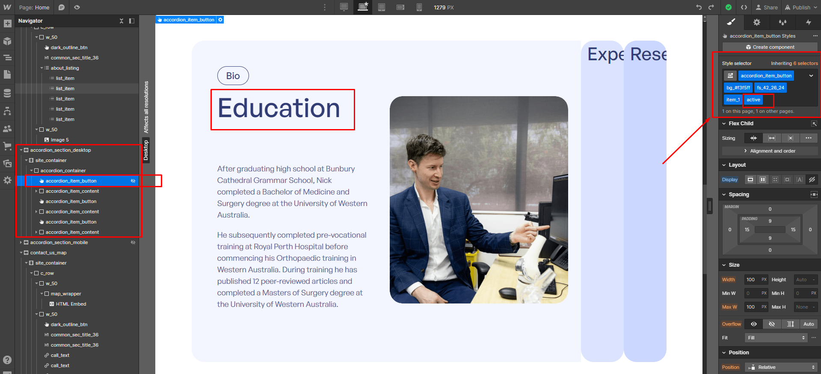

# **Accordion section for Mobile**

–To change the content of the accordion section for mobile, you need to set the viewport to the tablet size using the top bar. After that, the **accordion_section_mobile** element will be displayed, and you can edit it, as shown in the screenshot below.

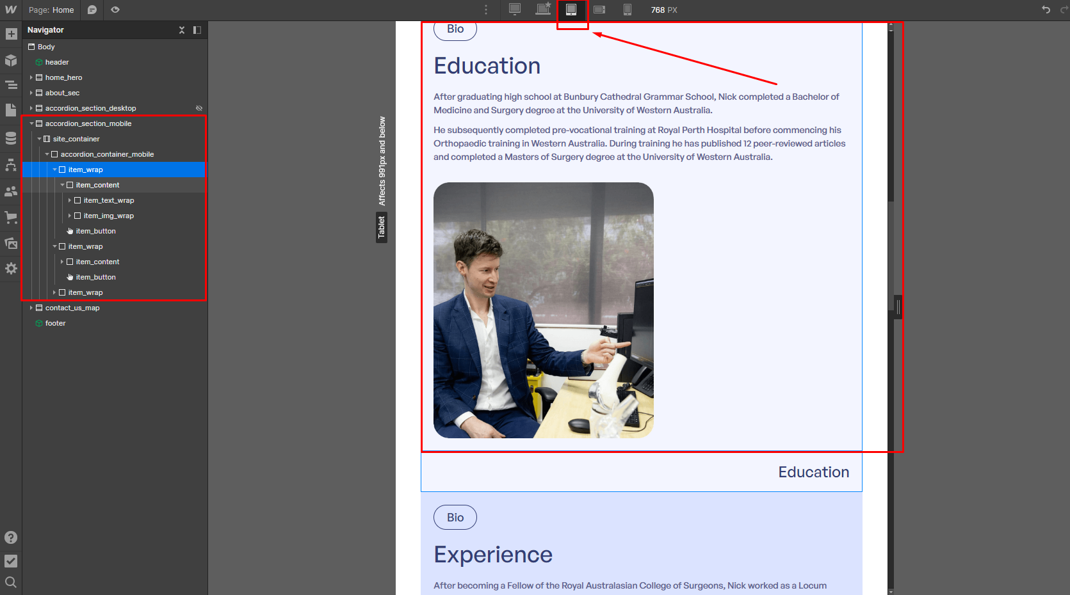

# 

# 

# 

# **Contact section with Map**

–For Map, to add Google Maps to Webflow, we need an API key. but For now, we've shown the map using the HTML iframe tag through the embed element.

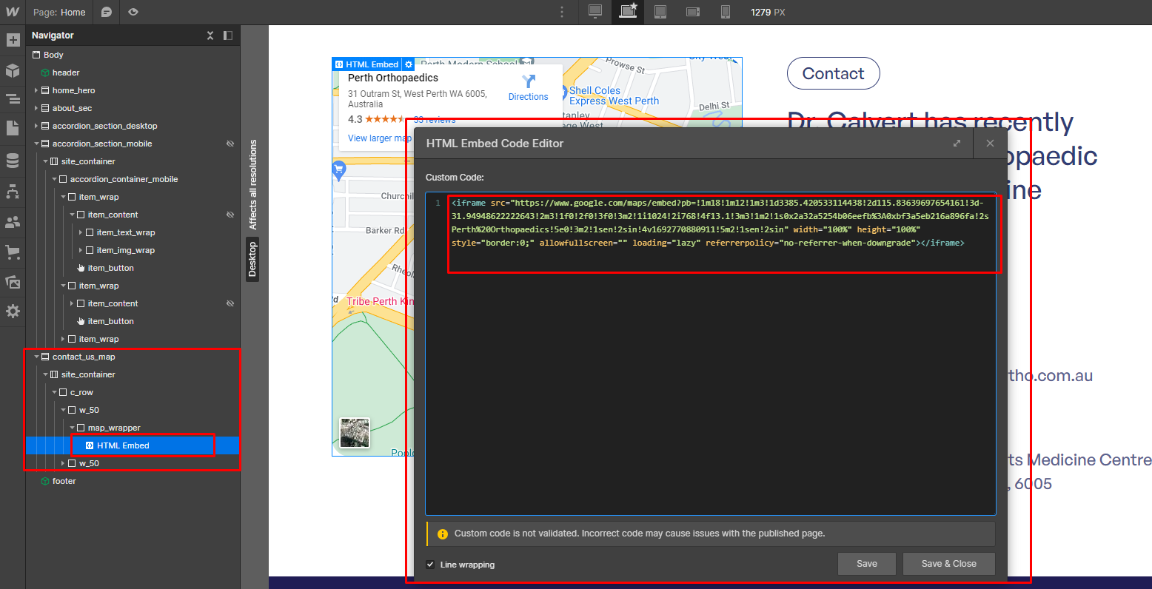

To change the map's location, you need to go to Google Maps, input the desired location, click on the embed option, copy the iframe code as shown in the screenshot below, then paste it into the embed Code editor (see above screenshot for embed editor) of the contact section,

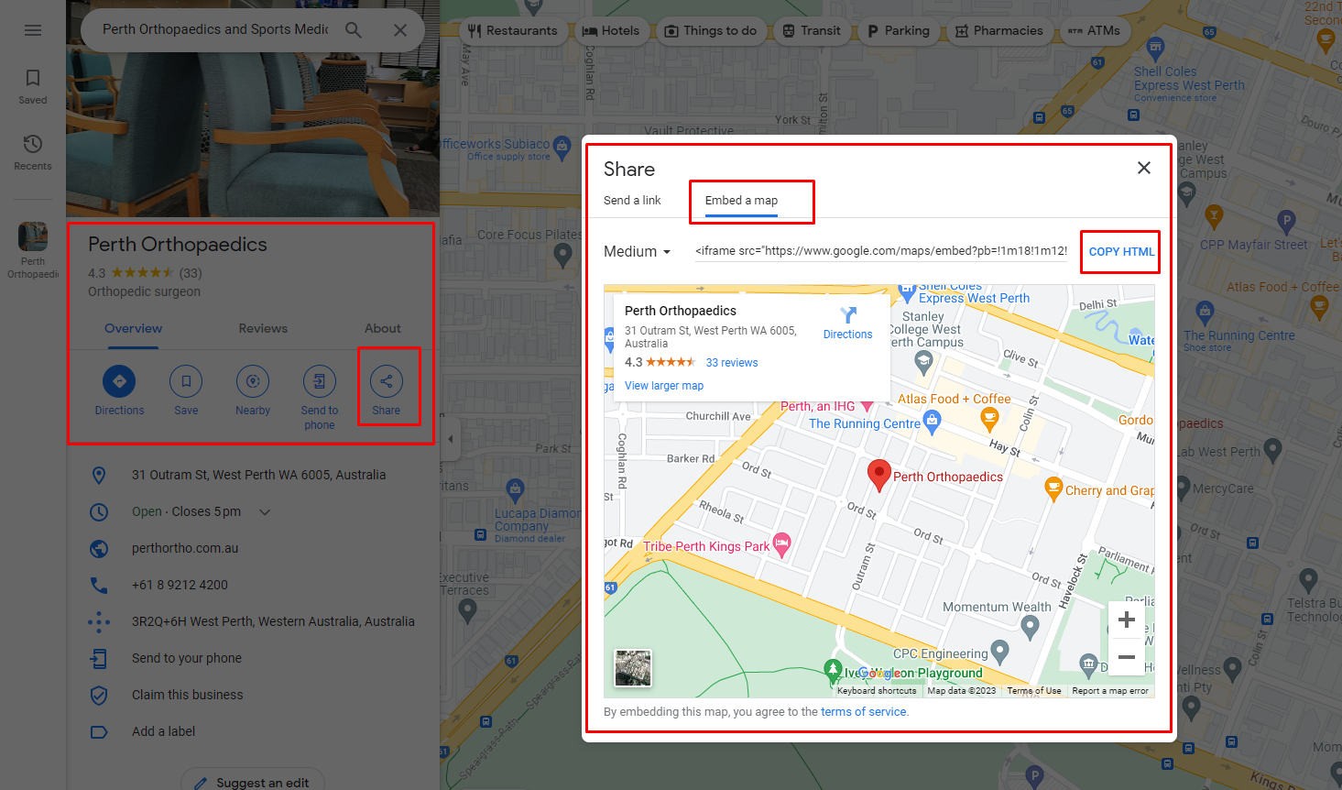

# **Faq Page:-**

**Faq Section**

–To edit the content of the FAQ section, you need to set the "**accordion_item_body**" element to "display: block" in the right-side style panel to make it visible. After making the changes, you should set it back to "display: none" as shown in the screenshot below.

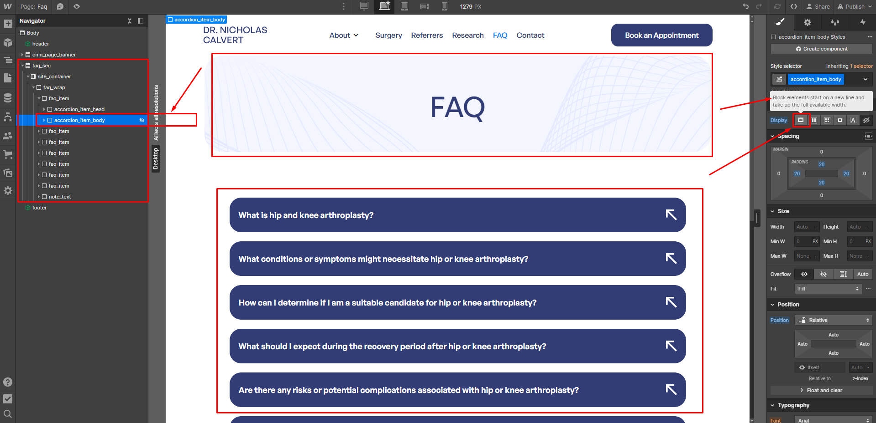

# **Surgery Page:-**

**Surgery Page POST content**

On the Surgery page, we have used **CMS Collections**. To change or add data, you need to click on the **CMS** option in the left sidebar, as shown in the screenshot below.

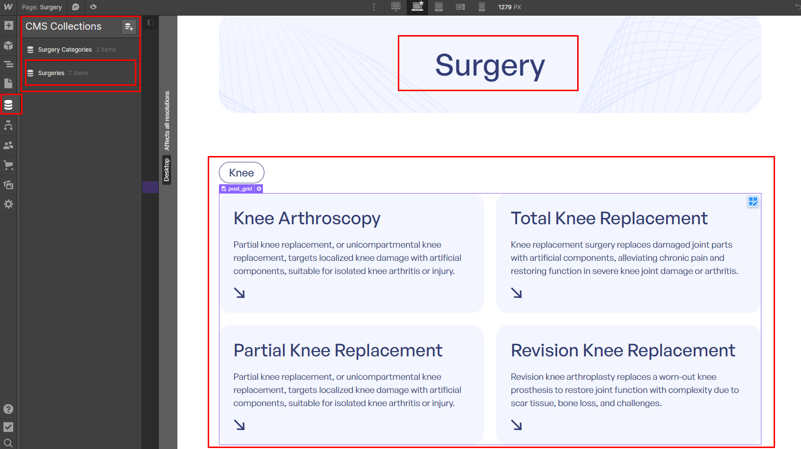

Now you will see all the Surgery-related posts, and you can change their data or add new posts, as shown in the screenshot below.

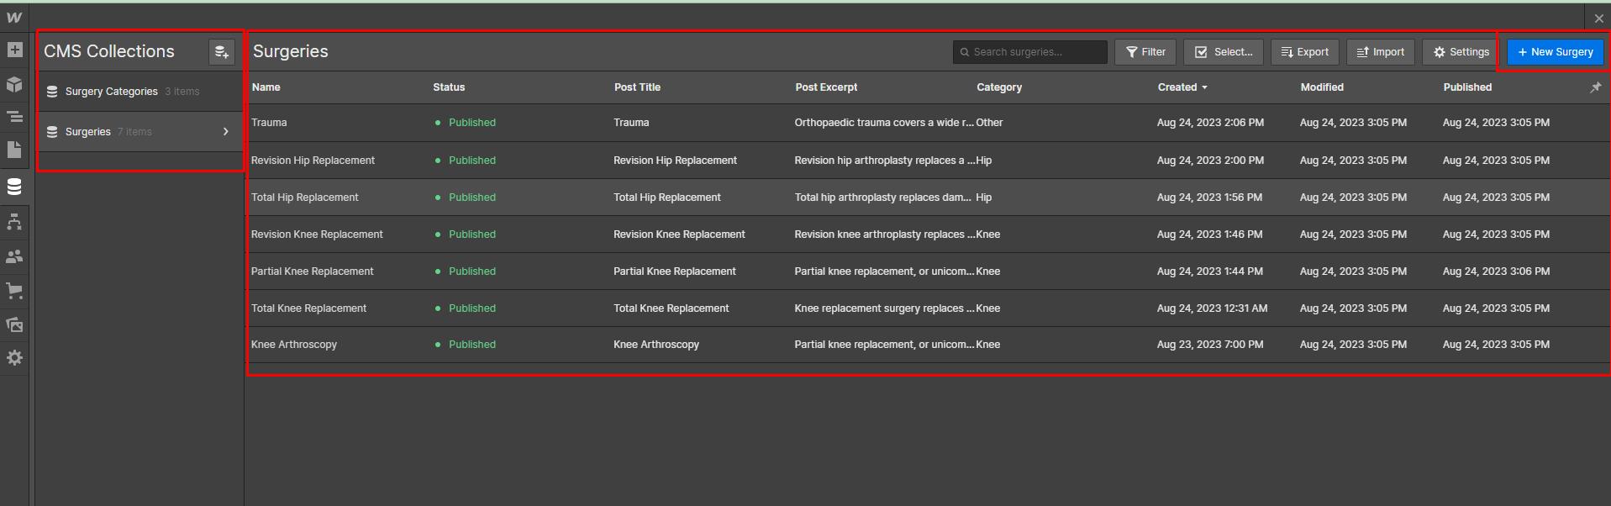

To manage the category for Surgery, you need to click on the Surgery Category option, where you can add or change categories, as shown in the screenshot below.

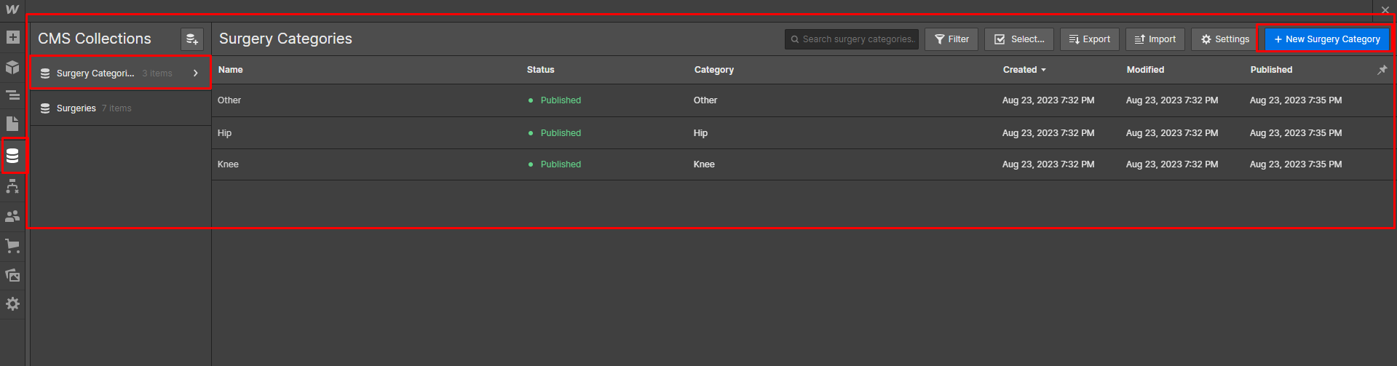

You can see all the categories that you have created while creating or editing a post. You must assign a category when adding a Surgery post, as shown in the screenshot below.

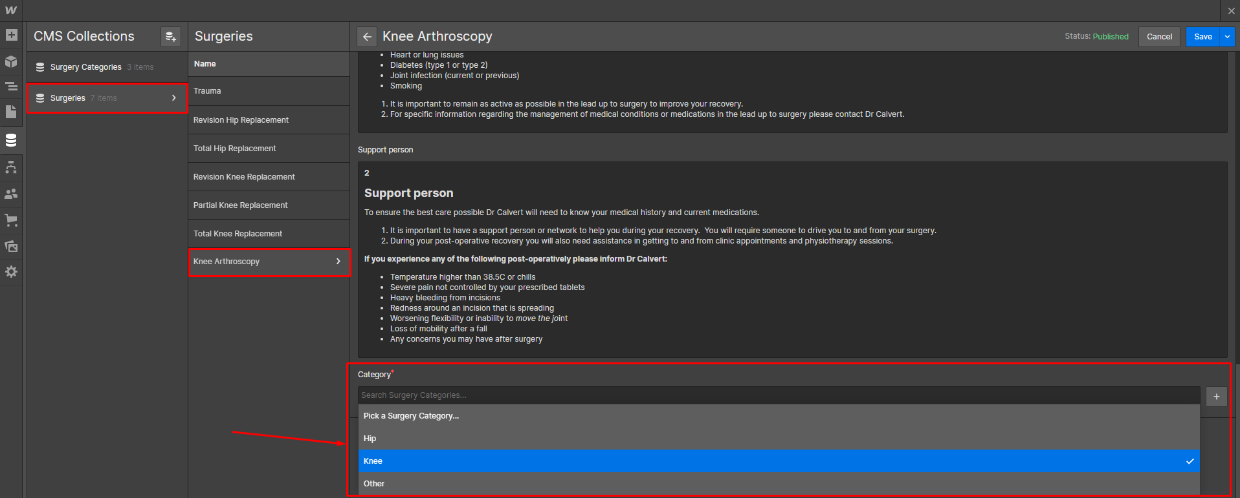

# **How to customize website Footer**

Click on the Navigator button to select the Footer then click on the edit icon as shown in the screenshot below.

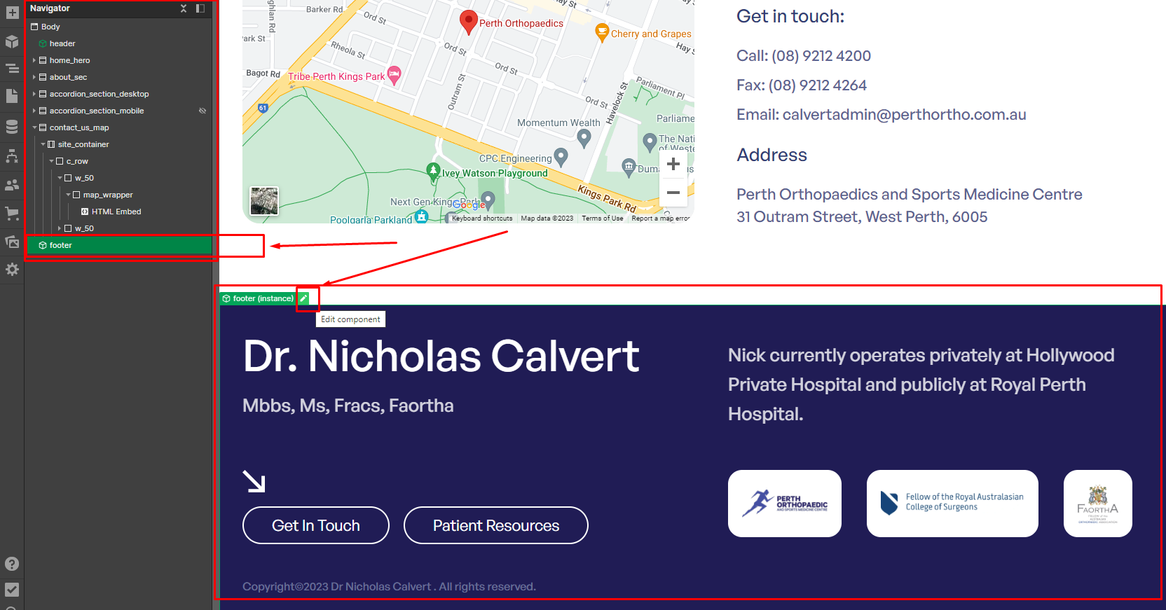

Click on the element that you want to change, as shown in the screenshot below.

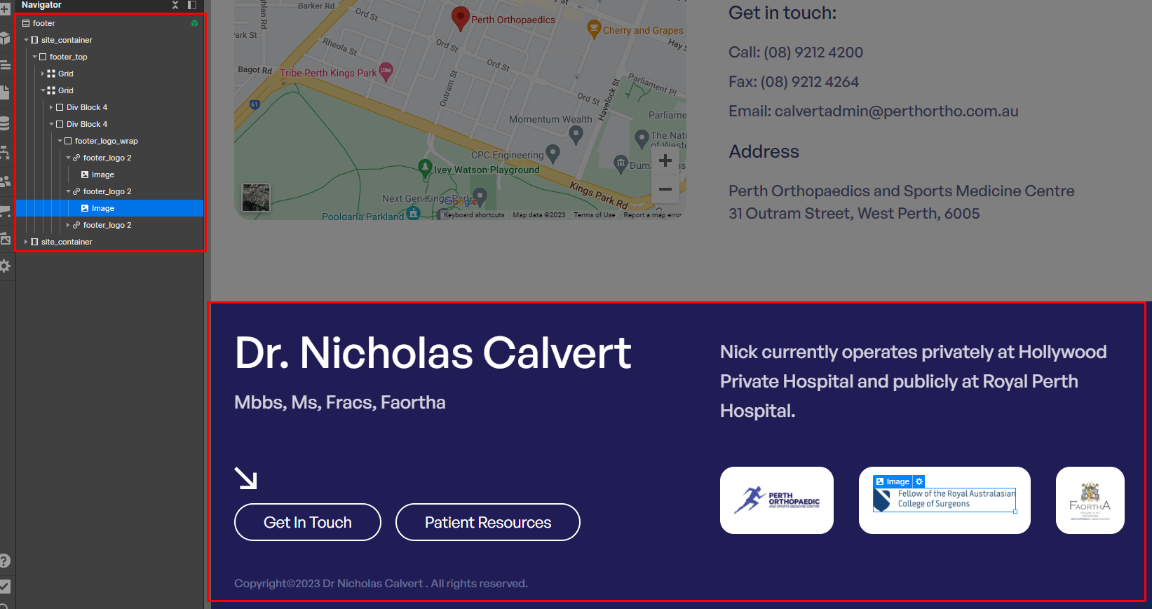

**We have added custom CSS code for styling and JavaScript code for the FAQ, accordion section, and Surgery page modal. Kindly do not delete it, as shown in the screenshot below.**

